**Visualization Tool for Electric Vehicle Charge and Range Analysis**

**PROJECT REPORT**

**Category**: Data Analytics With Tableau

NM_ID: B413E95045E890AB5054DF7586EF0D0A

Team ID: **NM2023TMID09882**

Internship at: SmartInternz

|  |  |
| --- | --- |
| Team Lead | **SATHANA S** |
| Team Members | **PUNITHAMERY Y** |
| **RAMYAKRISHNA T** |
| **SOUNDARYA S** |

**Email Id: [sathanasankar06@gmail.com](mailto:abiramyakila@gmail.com)**

**INTRODUCTION**

**1.1 Overview**

The Visualization Tool for Electric Vehicle Charge and Range Analysis is a software program that enables users to analyze and visualize data related to electric vehicle charging and range. The tool provides users with real-time information about the status of their electric vehicles, including battery charge level, estimated range, and charging station availability. It can also be used to track charging and driving patterns, and to optimize routes for maximum efficiency.

The tool works by integrating with the vehicle's on-board diagnostics system and collecting data on battery charge level, driving distance, and other relevant metrics. This data is then analyzed and presented to the user in an intuitive graphical interface, which allows them to easily identify patterns and trends.

The tool is useful for both individual electric vehicle owners and fleet operators, as it provides a comprehensive view of vehicle usage and enables users to optimize their charging and driving practices. It can also be used by charging station operators to monitor usage and identify areas for improvement.

Overall, the Visualization Tool for Electric Vehicle Charge and Range Analysis is a powerful tool for electric vehicle users and operators, providing valuable insights into vehicle usage and enabling more efficient and effective management of charging and driving practices.

**1.2 Purpose**

The purpose of a visualization tool for electric vehicle (EV) charge and range analysis is to provide a clear and easy-to-understand representation of the charging and range status of an EV. This tool can help EV owners, fleet managers, and other stakeholders to make informed decisions about how and when to charge their vehicles, how far they can travel on a single charge, and other factors that affect the overall performance of the vehicle.

Some of the specific benefits of a visualization tool for EV charge and range analysis include:

Understanding charging patterns: A visualization tool can help EV owners and fleet managers understand how and when their vehicles are being charged, which can help them optimize charging patterns to save time and money. Planning trips: By providing real-time information about the remaining range of an EV, a visualization tool can help drivers plan their trips more effectively and avoid running out of power in the middle of a journey.

* Identifying charging stations: A visualization tool can also help drivers locate nearby charging stations, which is particularly important when planning longer journeys.
* Optimizing battery life: By providing information about how different driving patterns and charging strategies affect battery life, a visualization tool can help drivers extend the lifespan of their batteries and avoid costly replacements.
* Overall, a visualization tool for EV charge and range analysis can help EV owners and fleet managers make more informed decisions about how to use and maintain their vehicles, which can lead to cost savings, improved performance, and a more sustainable transportation system.

**PROBLEM DEFINITION & DESIGN THINKING**

**2.1 Empathy Map**

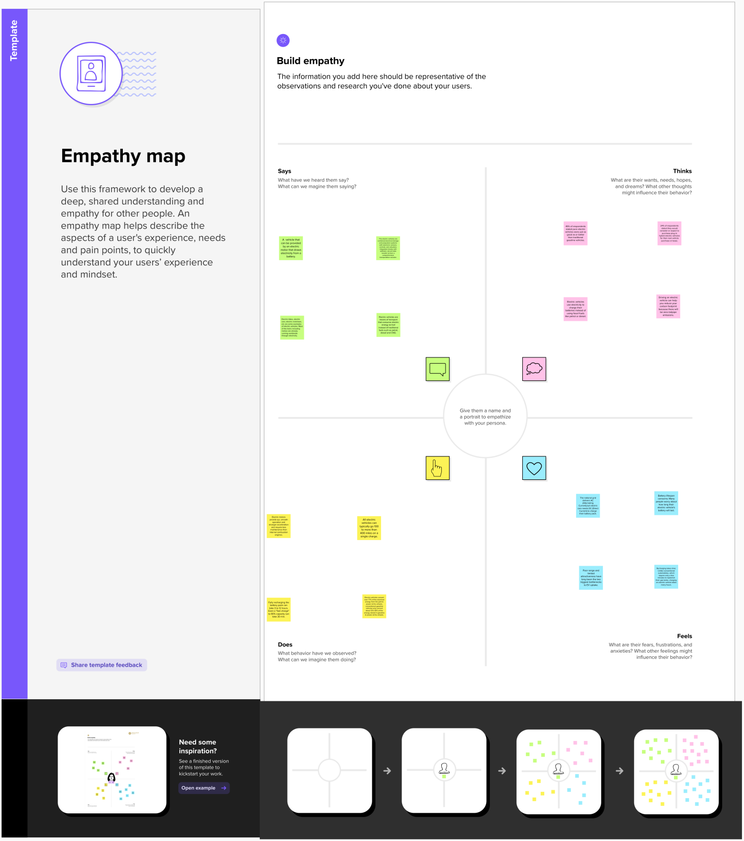

**2.2 Ideation & Brainstorming Map**

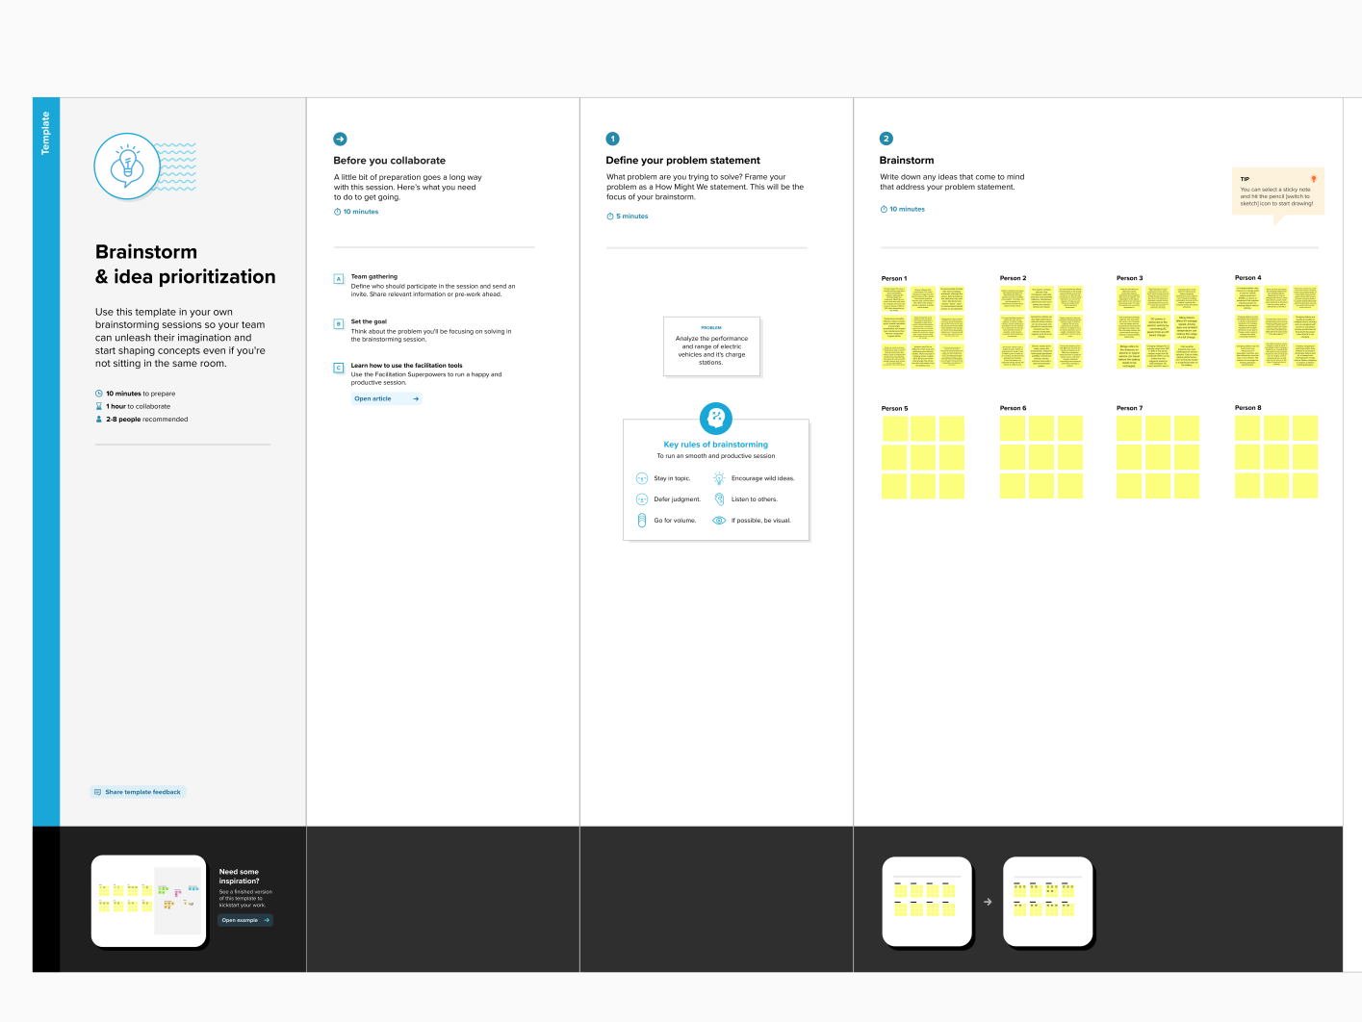

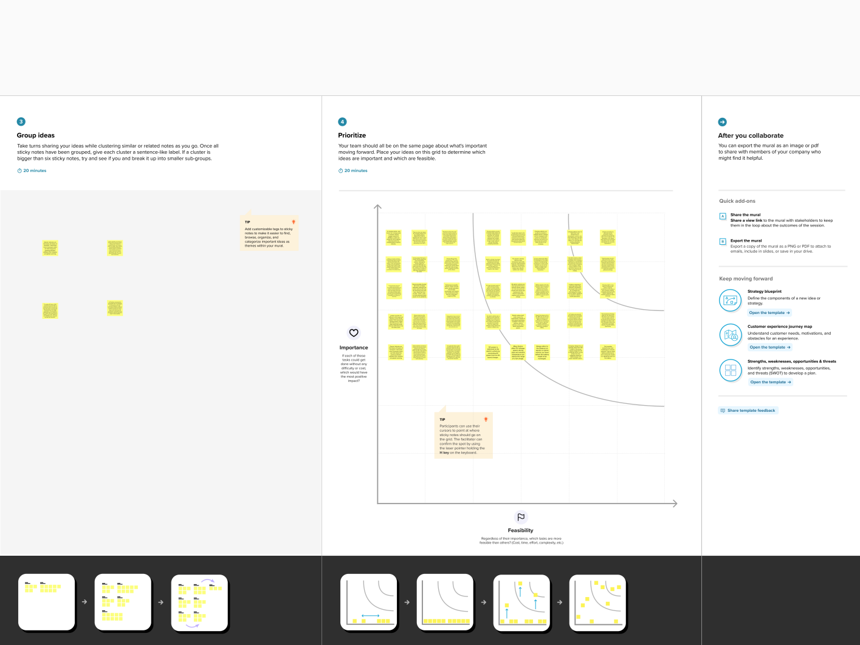

**RESULT**

**Screenshots of output:**

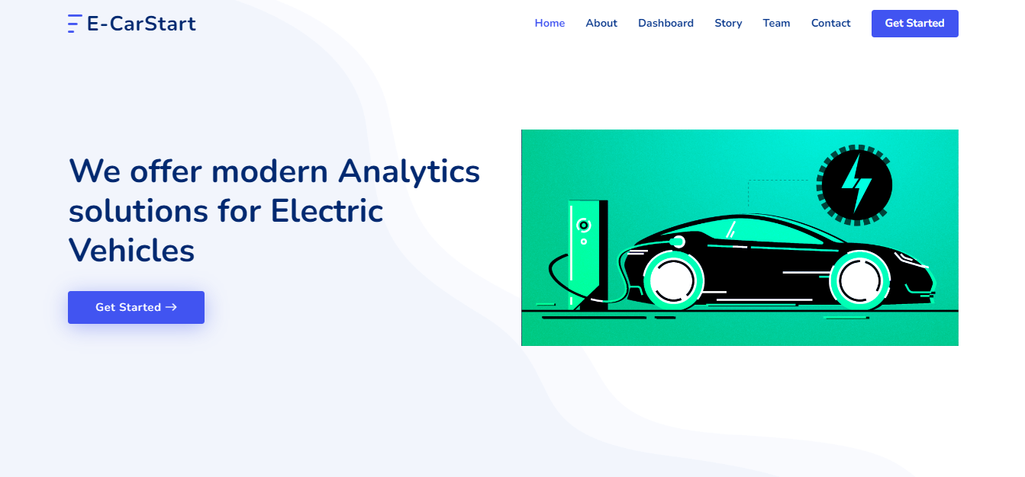

**Fig 3.1 Project WebPages**

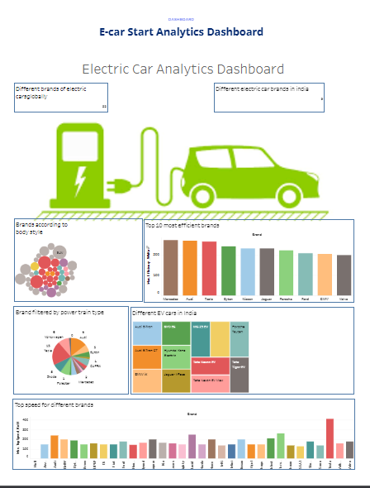**Fig 3.2 Dashboard webpage**

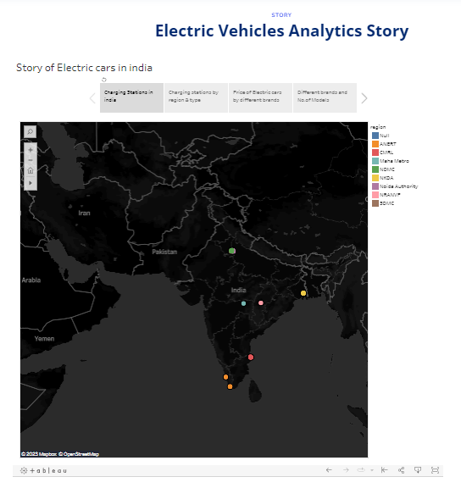

**Fig 3.3 Story Webpage**

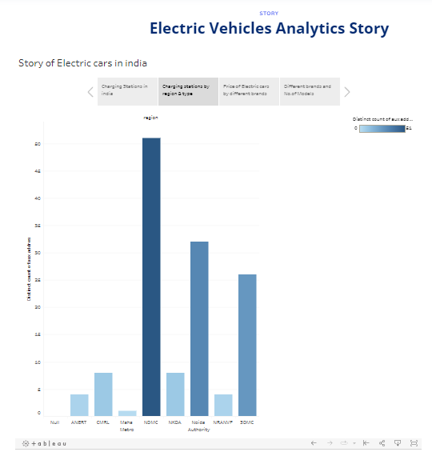

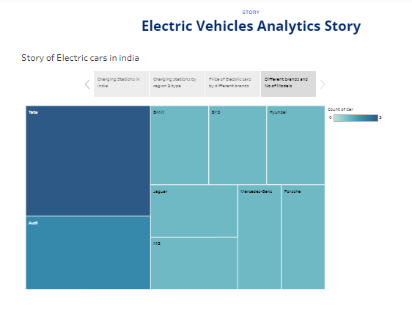**Fig 3.4 Story Webpage**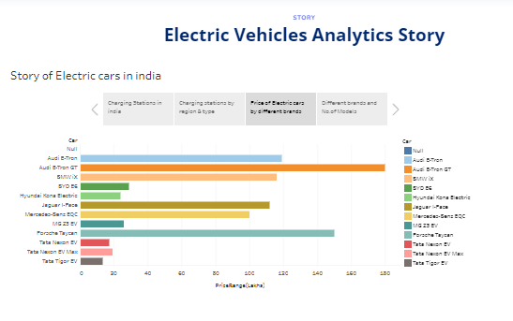

**Fig 3.5 Story Webpage**

**ADVANTAGES & DISADVANTAGES**

**Advantages:**

Visualization tools can be extremely helpful for electric vehicle (EV) charge and range analysis, as they can provide a clear and intuitive representation of complex data sets. Here are some of the advantages of using visualization tools for EV charge and range analysis:

* Improved Understanding: Visualization tools can help EV owners better understand how much range they have left, and how far they can travel on a single charge. This can be particularly useful when planning long trips or navigating unfamiliar areas.
* Real-Time Data: Many visualization tools provide real-time data on battery levels, range, and charging times. This can help EV owners make more informed decisions about when and where to charge their vehicle.
* Customization: Visualization tools can be customized to display the specific data points that are most relevant to the user. This can help EV owners focus on the information that is most important to them, and make more informed decisions about charging and driving.
* Predictive Analytics: Some visualization tools use predictive analytics to estimate how much range an EV will have based on factors such as driving style, weather conditions, and traffic.
* Overall, visualization tools can be an incredibly useful tool for EV owners looking to better understand their vehicle's performance, and to make informed decisions about charging and driving.

**Disadvantages:**

* Limited accuracy: Visualization tools for electric vehicle charge and range analysis often rely on data from various sources, including weather forecasts, traffic conditions, and charging station availability. However, these data sources may not always be accurate, leading to inaccurate predictions and results.
* Dependency on data connectivity: Many visualization tools require a stable and reliable internet connection to function properly. This can be a problem in areas with poor connectivity or in situations where the user does not have access to the internet.
* Limited data coverage: While some visualization tools may provide a comprehensive view of charging station locations and availability, others may have limited coverage and may not include all charging stations in a given area. This can be a problem for users who rely on these tools to plan their trips.
* Inability to account for individual driving habits: Visualization tools may provide general information about electric vehicle range and charging, but they may not be able to account for individual driving habits.
* Cost: Some visualization tools may require a subscription or purchase, which may be a barrier for some users. Additionally, some tools may only be available on certain platforms or devices, further limiting accessibility.

**APPLICATIONS**

Visualization tools can be a powerful way to analyze and understand electric vehicle (EV) charge and range data. Here are some possible applications of visualization tools for EV charge and range analysis:

* Understanding charging patterns: Visualization tools can help identify charging patterns over time, such as how often and when the EV is charged. This information can be useful for optimizing charging schedules and predicting charging needs.
* Monitoring charging infrastructure: Visualization tools can also be used to monitor charging infrastructure, including the number of charging stations and their usage patterns. This can be helpful for identifying areas where more charging infrastructure is needed.
* Predicting range: Visualization tools can use EV charging data to predict the vehicle's range.
* Identifying charging outliers: Visualization tools can help identify charging sessions that are significantly different from the norm. For example, a charging session that takes much longer than expected may indicate a problem with the charging station or the vehicle's battery.
* Analyzing energy usage: Visualization tools can also be used to analyze energy usage during charging, including the amount of energy used per session and the cost of charging. This information can be helpful for optimizing charging schedules and reducing charging costs.
* Overall, visualization tools can provide valuable insights into EV charge and range data, helping EV owners and operators optimize charging schedules, plan trips, and better understand the performance of their vehicles.

**CONCLUSION**

In conclusion, the visualization tool for electric vehicle charge and range analysis is a valuable asset for electric vehicle owners and fleet managers. The tool provides a clear and detailed analysis of the charging infrastructure, energy consumption, and range of electric vehicles, enabling users to make informed decisions regarding route planning, charging schedules, and overall vehicle usage.

Through the visualization tool, users can track and monitor their electric vehicle's battery state of charge, estimated driving range, and charging status in real-time, ensuring that they have the necessary information to plan their trips accordingly. Additionally, the tool can help users identify areas with high electric vehicle adoption rates, charging station availability, and potential charging issues, enabling them to adjust their routes and schedules accordingly.

Overall, the visualization tool for electric vehicle charge and range analysis is an essential tool for electric vehicle owners and fleet managers looking to optimize their vehicle's usage, reduce range anxiety, and minimize operating costs. It provides a comprehensive and intuitive overview of electric vehicle performance, charging infrastructure, and range limitations, empowering users to make informed decisions and maximize their electric vehicle's potential.

**FUTURE SCOPE**

The future scope of a visualization tool for electric vehicle charge and range analysis is quite promising. With the increasing popularity of electric vehicles and the growing need for sustainable transportation, there is a great demand for tools that can help electric vehicle owners and fleet managers better understand the charging and range capabilities of their vehicles.

Here are some potential future developments in this field:

Integration with smart charging infrastructure: As electric vehicle charging infrastructure becomes more advanced and intelligent, it will be possible to integrate visualization tools with smart charging systems to optimize charging and range management.

Enhanced data analytics: Advanced data analytics can help identify patterns and trends in charging and range data that can be used to improve vehicle performance and inform decision-making.

Integration with navigation systems: Integration with navigation systems can help electric vehicle owners plan their routes and charging stops more effectively, taking into account factors such as traffic and charging station availability.

Integration with vehicle telematics: Integration with vehicle telematics can provide real-time data on vehicle performance and enable predictive maintenance to optimize vehicle uptime and performance.

Integration with renewable energy sources: As renewable energy sources become more prevalent, visualization tools can help electric vehicle owners and fleet managers optimize their charging and range based on the availability of renewable energy.

Overall, the future of visualization tools for electric vehicle charge and range analysis is exciting; with significant potential for innovation and growth as the electric vehicle market continues to expand.

**APPENDIXTop of Form**

**SOURCE CODE:**

<!DOCTYPE html>

<html lang="en">

<head>

<meta charset="utf-8">

<meta content="width=device-width, initial-scale=1.0" name="viewport">

<title>FlexStart Bootstrap Template - Index</title>

<meta content="" name="description">

<meta content="" name="keywords">

<!-- Favicons -->

<link href="assets/img/favicon.png" rel="icon">

<link href="assets/img/apple-touch-icon.png" rel="apple-touch-icon">

<!-- Google Fonts -->

<link href="https://fonts.googleapis.com/css?family=Open+Sans:300,300i,400,400i,600,600i,700,700i|Nunito:300,300i,400,400i,600,600i,700,700i|Poppins:300,300i,400,400i,500,500i,600,600i,700,700i" rel="stylesheet">

<!-- Vendor CSS Files -->

<link href="assets/vendor/aos/aos.css" rel="stylesheet">

<link href="assets/vendor/bootstrap/css/bootstrap.min.css" rel="stylesheet">

<link href="assets/vendor/bootstrap-icons/bootstrap-icons.css" rel="stylesheet">

<link href="assets/vendor/glightbox/css/glightbox.min.css" rel="stylesheet">

<link href="assets/vendor/remixicon/remixicon.css" rel="stylesheet">

<link href="assets/vendor/swiper/swiper-bundle.min.css" rel="stylesheet">

<!-- Template Main CSS File -->

<link href="assets/css/style.css" rel="stylesheet">

<!-- =======================================================

* Template Name: FlexStart

* Updated: Mar 10 2023 with Bootstrap v5.2.3

* Template URL: https://bootstrapmade.com/flexstart-bootstrap-startup-template/

* Author: BootstrapMade.com

* License: https://bootstrapmade.com/license/

======================================================== -->

</head>

<body>

<!-- ======= Header ======= -->

<header id="header" class="header fixed-top">

<div class="container-fluid container-xl d-flex align-items-center justify-content-between">

<a href="index.html" class="logo d-flex align-items-center">

<img src="assets/img/logo.png" alt="">

<span>E-CarStart</span>

</a>

<nav id="navbar" class="navbar">

<ul>

<li><a class="nav-link scrollto active" href="#hero">Home</a></li>

<li><a class="nav-link scrollto" href="#about">About</a></li>

<li><a class="nav-link scrollto" href="#services">Dashboard</a></li>

<li><a class="nav-link scrollto" href="#portfolio">Story</a></li>

<li><a class="nav-link scrollto" href="#team">Team</a></li>

<li><a class="nav-link scrollto" href="#contact">Contact</a></li>

<li><a class="getstarted scrollto" href="#about">Get Started</a></li>

</ul>

<i class="bi bi-list mobile-nav-toggle"></i>

</nav><!-- .navbar -->

</div>

</header><!-- End Header -->

<!-- ======= Hero Section ======= -->

<section id="hero" class="hero d-flex align-items-center">

<div class="container">

<div class="row">

<div class="col-lg-6 d-flex flex-column justify-content-center">

<h1 data-aos="fade-up">We offer modern Analytics solutions for Electric Vehicles</h1>

<div data-aos="fade-up" data-aos-delay="600">

<div class="text-center text-lg-start">

<a href="#about" class="btn-get-started scrollto d-inline-flex align-items-center justify-content-center align-self-center">

<span>Get Started</span>

<i class="bi bi-arrow-right"></i>

</a>

</div>

</div>

</div>

<div class="col-lg-6 hero-img" data-aos="zoom-out" data-aos-delay="200">

<img src="assets/img/hero-img.png" class="img-fluid" alt="">

</div>

</div>

</div>

</section><!-- End Hero -->

<main id="main">

<!-- ======= About Section ======= -->

<section id="about" class="about">

<div class="container" data-aos="fade-up">

<div class="row gx-0">

<div class="col-lg-6 d-flex flex-column justify-content-center" data-aos="fade-up" data-aos-delay="200">

<div class="content">

<h3>About the Project</h3>

<p>

The "Visualization Tool for Electric Vehicle Charge and Range Analysis" is a software application that helps electric vehicle (EV) owners analyzes their vehicle's charge level and range. The tool takes into account various factors such as battery capacity, driving habits, and charging infrastructure, to provide users with an estimate of their vehicle's range and charging requirements. The tool then presents this information in a visually appealing and easy-to-understand format, allowing users to quickly make informed decisions about their driving and charging habits. The project involves designing and developing a user-friendly interface and incorporating algorithms that accurately calculate and visualize the EV's charge and range data.

</p>

<div class="text-center text-lg-start">

<a href="#" class="btn-read-more d-inline-flex align-items-center justify-content-center align-self-center">

<span>Read More</span>

<i class="bi bi-arrow-right"></i>

</a>

</div>

</div>

</div>

<div class="col-lg-6 d-flex align-items-center" data-aos="zoom-out" data-aos-delay="200">

<img src="assets/img/about.jpg" class="img-fluid" alt="">

</div>

</div>

</div>

</section><!-- End About Section -->

<!-- ======= Features Section ======= -->

<section id="features" class="features">

<div class="container" data-aos="fade-up">

<header class="section-header">

<h2>Features</h2>

<p>There are many features of our project</p>

</header>

<div class="row">

<div class="col-lg-6">

<img src="assets/img/features.png" class="img-fluid" alt="">

</div>

<div class="col-lg-6 mt-5 mt-lg-0 d-flex">

<div class="row align-self-center gy-4">

<div class="col-md-6" data-aos="zoom-out" data-aos-delay="200">

<div class="feature-box d-flex align-items-center">

<i class="bi bi-check"></i>

<h3>Analyse the current status</h3>

</div>

</div>

<div class="col-md-6" data-aos="zoom-out" data-aos-delay="300">

<div class="feature-box d-flex align-items-center">

<i class="bi bi-check"></i>

<h3>Get to know EV more</h3>

</div>

</div>

<div class="col-md-6" data-aos="zoom-out" data-aos-delay="400">

<div class="feature-box d-flex align-items-center">

<i class="bi bi-check"></i>

<h3>Know about charging stations</h3>

</div>

</div>

<div class="col-md-6" data-aos="zoom-out" data-aos-delay="500">

<div class="feature-box d-flex align-items-center">

<i class="bi bi-check"></i>

<h3>Top performing Brands</h3>

</div>

</div>

<div class="col-md-6" data-aos="zoom-out" data-aos-delay="600">

<div class="feature-box d-flex align-items-center">

<i class="bi bi-check"></i>

<h3>Different brands in india<h3>

</div>

</div>

<div class="col-md-6" data-aos="zoom-out" data-aos-delay="700">

<div class="feature-box d-flex align-items-center">

<i class="bi bi-check"></i>

<h3>Different brands Globally</h3>

</div>

</div>

</div>

</div>

</div> <!-- / row -->

<!-- Feature Tabs -->

<div class="row feture-tabs" data-aos="fade-up">

<div class="col-lg-6">

<h3>Overview of Electric Vehicle Sector</h3>

<!-- Tabs -->

<ul class="nav nav-pills mb-3">

<li>

<a class="nav-link active" data-bs-toggle="pill" href="#tab1">Overview</a>

</li>

<li>

<a class="nav-link" data-bs-toggle="pill" href="#tab2">Pricing</a>

</li>

</ul><!-- End Tabs -->

<!-- Tab Content -->

<div class="tab-content">

<div class="tab-pane fade show active" id="tab1">

<p>The Visualization Tool for Electric Vehicle Charge and Range Analysis is a software program that enables users to analyze and visualize data related to electric vehicle charging and range. The tool provides users with real-time information about the status of their electric vehicles, including battery charge level, estimated range, and charging station availability. It can also be used to track charging and driving patterns, and to optimize routes for maximum efficiency.

The tool works by integrating with the vehicle's on-board diagnostics system and collecting data on battery charge level, driving distance, and other relevant metrics. This data is then analyzed and presented to the user in an intuitive graphical interface, which allows them to easily identify patterns and trends.</p>

</div><!-- End Tab 1 Content -->

<div class="tab-pane fade show" id="tab2">

<p>The pricing for electric vehicle (EV) charging can vary depending on several factors such as:

Location: Charging rates can vary based on the region, city, or even the specific charging station. Some areas may have higher electricity rates or additional taxes that can affect the charging cost.

Charging station provider: Different charging station providers may have different pricing models, depending on their network and infrastructure.

Charging speed: Faster charging speeds may come at a higher cost than slower charging options.

Time of use: Some charging providers may offer reduced rates during off-peak hours, while others may have dynamic pricing that fluctuates based on demand.

Membership plans: Some charging providers may offer membership plans that include discounted charging rates or other perks.

</p>

</div><!-- End Tab 2 Content -->

</div>

</div>

<div class="col-lg-6">

<img src="assets/img/features-2.png" class="img-fluid" alt="">

</div>

</div><!-- End Feature Tabs -->

<!-- ======= Services Section ======= -->

<section id="services" class="services">

<div class="container" data-aos="fade-up"

<header class="section-header">

<h2>Dashboard</h2>

<p>E-car Start Analytics Dashboard</p>

</header>

<div class='tableauPlaceholder' id='viz1681110246182' style='position: relative'><noscript><a href='#'><img alt='Dashboard 1 ' src='https:&#47;&#47;public.tableau.com&#47;static&#47;images&#47;Bo&#47;Book1_16809723593620&#47;Dashboard1&#47;1_rss.png' style='border: none' /></a></noscript><object class='tableauViz' style='display:none;'><param name='host_url' value='https%3A%2F%2Fpublic.tableau.com%2F' /> <param name='embed_code_version' value='3' /> <param name='site_root' value='' /><param name='name' value='Book1_16809723593620&#47;Dashboard1' /><param name='tabs' value='no' /><param name='toolbar' value='yes' /><param name='static_image' value='https:&#47;&#47;public.tableau.com&#47;static&#47;images&#47;Bo&#47;Book1_16809723593620&#47;Dashboard1&#47;1.png' /> <param name='animate_transition' value='yes' /><param name='display_static_image' value='yes' /><param name='display_spinner' value='yes' /><param name='display_overlay' value='yes' /><param name='display_count' value='yes' /><param name='language' value='en-US' /></object></div> <script type='text/javascript'> var divElement = document.getElementById('viz1681110246182'); var vizElement = divElement.getElementsByTagName('object')[0]; if ( divElement.offsetWidth > 800 ) { vizElement.style.width='1320px';vizElement.style.height='2027px';} else if ( divElement.offsetWidth > 500 ) { vizElement.style.width='1320px';vizElement.style.height='2027px';} else { vizElement.style.width='100%';vizElement.style.height='2227px';} var scriptElement = document.createElement('script'); scriptElement.src = 'https://public.tableau.com/javascripts/api/viz_v1.js'; vizElement.parentNode.insertBefore(scriptElement, vizElement); </script>

</section><!-- End Services Section -->

<!-- ======= Portfolio Section ======= -->

<section id="portfolio" class="portfolio">

<div class="container" data-aos="fade-up">

<header class="section-header">

<h2>Story</h2>

<p>Electric Vehicles Analytics Story</p>

</header>

<div class='tableauPlaceholder' id='viz1681110518728' style='position: relative'><noscript><a href='#'><img alt='Story of Electric cars in india ' src='https:&#47;&#47;public.tableau.com&#47;static&#47;images&#47;Bo&#47;Book1_16809725015600&#47;StoryofElectriccarsinindia&#47;1_rss.png' style='border: none' /></a></noscript><object class='tableauViz' style='display:none;'><param name='host_url' value='https%3A%2F%2Fpublic.tableau.com%2F' /> <param name='embed_code_version' value='3' /> <param name='site_root' value='' /><param name='name' value='Book1_16809725015600&#47;StoryofElectriccarsinindia' /><param name='tabs' value='no' /><param name='toolbar' value='yes' /><param name='static_image' value='https:&#47;&#47;public.tableau.com&#47;static&#47;images&#47;Bo&#47;Book1_16809725015600&#47;StoryofElectriccarsinindia&#47;1.png' /> <param name='animate_transition' value='yes' /><param name='display_static_image' value='yes' /><param name='display_spinner' value='yes' /><param name='display_overlay' value='yes' /><param name='display_count' value='yes' /><param name='language' value='en-US' /></object></div> <script type='text/javascript'> var divElement = document.getElementById('viz1681110518728'); var vizElement = divElement.getElementsByTagName('object')[0]; vizElement.style.width='1016px';vizElement.style.height='991px'; var scriptElement = document.createElement('script'); scriptElement.src = 'https://public.tableau.com/javascripts/api/viz_v1.js'; vizElement.parentNode.insertBefore(scriptElement, vizElement); </script>

</section><!-- End Portfolio Section -->

<!-- ======= Team Section ======= -->

<section id="team" class="team">

<div class="container" data-aos="fade-up">

<header class="section-header">

<h2>Team</h2>

<p>Our hard working team</p>

</header>

<div class="row gy-4">

<div class="col-lg-3 col-md-6 d-flex align-items-stretch" data-aos="fade-up" data-aos-delay="100">

<div class="member">

<div class="member-img">

<div class="social">

<a href=""><i class="bi bi-twitter"></i></a>

<a href=""><i class="bi bi-facebook"></i></a>

<a href=""><i class="bi bi-instagram"></i></a>

<a href=""><i class="bi bi-linkedin"></i></a>

</div>

</div>

<div class="member-info">

<h4>ArunKumar M</h4>

<span>Team Leader</span>

</div>

</div>

</div>

<div class="col-lg-3 col-md-6 d-flex align-items-stretch" data-aos="fade-up" data-aos-delay="200">

<div class="member">

<div class="member-img">

<div class="social">

<a href=""><i class="bi bi-instagram"></i></a>

<a href=""><i class="bi bi-linkedin"></i></a>

</div>

</div>

<div class="member-info">

<h4>ArulKumar M</h4>

<span>Team Member</span>

</div>

</div>

</div>

<div class="col-lg-3 col-md-6 d-flex align-items-stretch" data-aos="fade-up" data-aos-delay="300">

<div class="member">

<div class="member-img">

<div class="social">

<a href=""><i class="bi bi-instagram"></i></a>

<a href=""><i class="bi bi-linkedin"></i></a>

</div>

</div>

<div class="member-info">

<h4>Elakya R</h4>

<span>Team Member</span>

</div>

</div>

</div>

<div class="col-lg-3 col-md-6 d-flex align-items-stretch" data-aos="fade-up" data-aos-delay="400">

<div class="member">

<div class="member-img">

<div class="social">

<a href=""><i class="bi bi-instagram"></i></a>

<a href=""><i class="bi bi-linkedin"></i></a>

</div>

</div>

<div class="member-info">

<h4>Mahesh K</h4>

<span>Team Member</span>

</div>

</div>

</div>

</div>

</div>

</section><!-- End Team Section -->

<!-- ======= Contact Section ======= -->

<section id="contact" class="contact">

<div class="container" data-aos="fade-up">

<header class="section-header">

<h2>Contact</h2>

<p>Contact Us</p>

</header>

<div class="row gy-4">

<div class="col-lg-6">

<div class="row gy-4">

<div class="col-md-6">

<div class="info-box">

<i class="bi bi-geo-alt"></i>

<h3>Address</h3>

<p>KGISL Campus,<br>Coimbatore-641035</p>

</div>

</div>

<div class="col-md-6">

<div class="info-box">

<i class="bi bi-telephone"></i>

<h3>Call Us</h3>

<p>+91 2198482378<br>+91 9283576329</p>

</div>

</div>

<div class="col-md-6">

<div class="info-box">

<i class="bi bi-envelope"></i>

<h3>Email Us</h3>

<p>info@kgisl.com</p>

</div>

</div>

<div class="col-md-6">

<div class="info-box">

<i class="bi bi-clock"></i>

<h3>Open Hours</h3>

<p>Monday - Friday<br>9:00AM - 05:00PM</p>

</div>

</div>

</div>

</div>

</div>

</div>

</div>

</section><!-- End Contact Section -->

</main><!-- End #main -->

<!-- ======= Footer ======= -->

<footer id="footer" class="footer">

<div class="footer-newsletter">

<div class="container">

<div class="row justify-content-center">

<div class="col-lg-12 text-center">

<h4>Our Newsletter</h4>

<p>Tamen quem nulla quae legam multos aute sint culpa legam noster magna</p>

</div>

<div class="col-lg-6">

<form action="" method="post">

<input type="email" name="email"><input type="submit" value="Subscribe">

</form>

</div>

</div>

</div>

</div>

<div class="footer-top">

<div class="container">

<div class="row gy-4">

<div class="col-lg-5 col-md-12 footer-info">

<a href="index.html" class="logo d-flex align-items-center">

<img src="assets/img/logo.png" alt="">

<span>E-carStart</span>

</a>

<p>We offer modern Analytics solutions for Electric Vehicles.</p>

<div class="social-links mt-3">

<a href="#" class="instagram"><i class="bi bi-instagram"></i></a>

<a href="#" class="linkedin"><i class="bi bi-linkedin"></i></a>

</div>

</div>

<div class="col-lg-2 col-6 footer-links">

<h4>Useful Links</h4>

<ul>

<li><i class="bi bi-chevron-right"></i> <a href="#">Home</a></li>

<li><i class="bi bi-chevron-right"></i> <a href="#">About us</a></li>

<li><i class="bi bi-chevron-right"></i> <a href="#">Dashboard</a></li>

<li><i class="bi bi-chevron-right"></i> <a href="#">story</a></li>

<li><i class="bi bi-chevron-right"></i> <a href="#">Privacy policy</a></li>

</ul>

</div>

<div class="col-lg-3 col-md-12 footer-contact text-center text-md-start">

<h4>Contact Us</h4>

<p>

KG College Of Arts And Science <br>

Saravanampatti<br>

Coimbatore-641035<br><br>

<strong>Email:</strong> info@kgcas.com<br>

</p>

</div>

</div>

</div>

</div>

<div class="container">

<div class="copyright">

&copy; Copyright <strong><span>E-CarStart</span></strong>. All Rights Reserved

</div>

<div class="credits">

<!-- All the links in the footer should remain intact. -->

<!-- You can delete the links only if you purchased the pro version. -->

<!-- Licensing information: https://bootstrapmade.com/license/ -->

<!-- Purchase the pro version with working PHP/AJAX contact form: https://bootstrapmade.com/flexstart-bootstrap-startup-template/ -->

Designed by <a href="https://bootstrapmade.com/">BootstrapMade</a>

</div>

</div>

</footer><!-- End Footer -->

<a href="#" class="back-to-top d-flex align-items-center justify-content-center"><i class="bi bi-arrow-up-short"></i></a>

<!-- Vendor JS Files -->

<script src="assets/vendor/purecounter/purecounter_vanilla.js"></script>

<script src="assets/vendor/aos/aos.js"></script>

<script src="assets/vendor/bootstrap/js/bootstrap.bundle.min.js"></script>

<script src="assets/vendor/glightbox/js/glightbox.min.js"></script>

<script src="assets/vendor/isotope-layout/isotope.pkgd.min.js"></script>

<script src="assets/vendor/swiper/swiper-bundle.min.js"></script>

<script src="assets/vendor/php-email-form/validate.js"></script>

<!-- Template Main JS File -->

<script src="assets/js/main.js"></script>

</body>

</html>